The Spatially Varying Impact of Air Travel and Industrial Expenditure on Domestic Tourism in Indonesia
$Athalia Andria Loly Aruan^{1 }$, $Ellen Diva Ibanez^{1}$, $Faiz Iqbal I'tishom^{1}$, $Najwa Mu'izza Zayuara^{1}$, $Raafa Agna Rasyada^{1}$
Abstract—This study investigates the spatially varying influence of air travel accessibility and industrial expenditure on domestic tourism across Indonesian provinces. Using spatial regression approaches including Ordinary Least Squares (OLS), Geographically Weighted Regression (GWR), Geographically Weighted Logistic Regression (GWLR). We examine whether global relationships hold uniformly across space or if local variations exist. Key indicators such as micro enterprises were analyzed against the number of domestic tourists and tourism classifications. The results reveal substantial spatial heterogeneity, particularly captured by the GWR and GWLR models. Among the tested variations, the GWR model with an adaptive Gaussian kernel demonstrates the best fit based on AICc and$R^{2}$ values, outperforming both global and other local models. Visualization of local coefficients further supports the spatially non-stationary nature of the relationships, suggesting that tourism development is strongly influenced by localized economic and infrastructure conditions.

Index Terms—Air passenger volume, domestic tourism, geographically weighted regression, industrial expenditure, spatial heterogeneity, tourism accesibility

INTRODUCTION
In Indonesia, the tourism sector goes beyond leisure. It is a major contributor to the local economy. Tourism supports infrastructure development, provides jobs, and drives the creative sector. Given these impacts, measuring performance of this sector becomes essential. One way to measure the performance of this sector is by looking at the number of domestic tourists traveling across the archipelago. However, these numbers tell a mixed story. While some provinces attract millions of visitors, others remain relatively obscure. This uneven distribution raises an important question. What influences people in choosing where to travel?
Two questions often arise in this context: how accessible a place is, and how active its local economy remains. Air travel remains the fastest and most efficient way to connect the islands. Therefore, passenger numbers can serve as a useful indicator of accessibility. On the other hand, the value of a region’s industrial spending can also indicate a certain level of economic vitality, whether through better services, infrastructure, or business opportunities. Combined, these factors likely shape tourism patterns, not just within a province, but also in surrounding regions.
However, what works in one province does not guarantee that it will work in another. Given its diverse economy, geography, and culture, Indonesia needs a more flexible and location-specific way to understand these connections. This is where spatial analysis becomes the answer.
This study analyzes the spatial distribution and interaction of domestic tourism, industrial activity, and air travel across provinces. We use a set of spatial models, such as Geographically Weighted Regression (GWR) and Geographically Weighted Logistic Regression (GWLR) to examine local and regional patterns that may be missed by standard models. The results are also visualized to enhance understanding and applicability.
Ultimately, the goal is to give policymakers better tools to identify which areas need the most support, which areas have the greatest tourism potential, and how accessibility and economic activity play into both. With the right insights, Indonesia can build a more balanced, effective, and inclusive tourism strategy. Strategies that are tailored to each region, not just focused on the usual popular destinations.

Methodology

Data Preprocessing
Prior to analysis, several preprocessing steps were carried out:
- Handling missing values and inconsistent labels: missing or incomplete entries were addressed through imputation or exclusion, depending on the extent and context of the missingness. In addition, inconsistencies in province names between datasets were corrected to ensure successful spatial joins.
- Data aggregation: disaggregated time-series or sectoral data were aggregated into meaningful summary variables — such as total tourist arrivals, total flights, and industrial spending — to facilitate regression and spatial modeling.
- Logarithmic transformation: positively skewed variables (e.g., tourist counts, industrial expenditure) were log-transformed to stabilize variance and reduce heteroscedasticity.
- Normalization and scaling: numerical variables with different units were standardized using either z-score normalization or min–max scaling to ensure comparability, particularly for geographically weighted models.
- Spatial harmonization: geospatial preprocessing steps included geocoding, extracting centroids of each province, and aligning administrative boundaries to match attribute data. This ensured spatial consistency across datasets and enabled accurate spatial operations [1].

Exploratory Data Analysis
Exploratory analysis was performed to examine the distributional characteristics, inter-variable relationships, and spatial variation of key variables. The steps included:
- Descriptive statistics: such as minimum, maximum, mean, and standard deviation were computed to summarize each key variable (e.g., number of tourists, flight volume, industrial spending).
- Spatial visualization: choropleth maps were generated using mapview and ggplot2 to visualize spatial variation in domestic tourism, air accessibility, and industrial activity.
- Insight from aggregated variables: aggregated indicators helped reveal regional disparities and detect anomalies prior to modeling.
- Model preparation: The results of EDA informed variable selection and provided justification for spatial modeling (e.g., using centroids in GWR) [2].

Thematic Mapping
Thematic maps were developed using R-based GIS tools to highlight spatial disparities:
- Choropleth maps: these depicted variations in domestic tourist volumes, air travel accessibility, and industrial activity across provinces.
- Interactive maps: using mapview allowed for exploration of region-specific attributes.
- Static maps: from ggplot2 supported visual comparison and narrative building.
These visualizations revealed spatial clustering and regional disparities that guided further spatial analysis [3].

Spatial Dependency Testing
To examine the spatial structure of the data:
- Global Moran’s I: computed to detect overall spatial autocorrelation in both dependent variables and residuals from the OLS model.
- Local Indicators of Spatial Association (LISA): used to identify local spatial clusters (high-high, low-low) and outliers (high-low, low-high).
- Spatial weights matrices: constructed using queen contiguity with poly2nb() and nb2listw() to define neighborhood relationships between provinces.
These tests confirmed spatial heterogeneity, justifying the use of geographically weighted and count-based spatial models [4].

Regression Analysis
To understand the spatial relationships between domestic tourism, accessibility (air passenger volume), and industrial activity (labor expenditure in micro and small industries), a series of regression models were employed. These models range from global to local approaches, allowing for both general insights and spatially nuanced interpretations.

E.1. Ordinary Least Square (OLS)
OLS was used as a global model to estimate the average relationship between the number of domestic tourists (dependent variable) and predictors such as air passenger volume and industrial expenditure. The model assumes spatial stationarity across all provinces. However, residuals from the OLS model exhibited significant spatial autocorrelation, as evidenced by Global Moran’s I, suggesting that a global model may not adequately capture local spatial variations [7].
Model Specification:
${Tourism}_{i}{ = β}_{0} + β_{1}{Accessibility}_{i} + β_{2}{Industry}_{i} + ϵ_{i}$

E.2. Geographically Weighted Regression (GWR)
To address spatial nonstationarity, Geographically Weighted Regression (GWR) was employed. GWR allows model coefficients to vary by location, providing a localized understanding of how each predictor affects tourism outcomes across provinces. The [GWmodel] package was used with an adaptive Gaussian kernel as the base configuration [8].
In addition, to improve model selection and fit, several GWR kernel and bandwidth combinations were explored:
- Adaptive Gaussian kernel
- Fixed Gaussian kernel
- Adaptive Bisquare kernel
- Fixed Bisquare kernel
Each model was compared using the corrected Akaike Information Criterion (AICc). The model with the lowest AICc was selected as the most appropriate, and spatial maps of local coefficients and local R² were used to visualize regional disparities in predictor influence [5].
Model Formulation:
${Tourism}_{i}{ = β}_{0}(u_{i},v_{i}) + β_{1}(u_{i},v_{i}) . {Accessibility}_{i}$
$+ β_{2}{(u_{i},v_{i}) . Industry}_{i} + ϵ_{i}$
where $(u_{i},v_{i})$ are the coordinates of location (i).

E.3. Geographically Weighted Logistic Regression (GWLR)
GWLR is used when the dependent variable is binary—for example, whether a province qualifies as a major tourism destination (1 = ‘yes’, 0 = ‘no’). The model estimates local regression coefficients, allowing the effect of each predictor (e.g., air travel accessibility, industrial expenditure) to vary across geographic space [9].
Model Specification:
${logit(P}_{i}){ = β}_{0}(u_{i},v_{i}) + β_{1}(u_{i},v_{i}) . {Accessibility}_{i}$
$+ β_{2}{(u_{i},v_{i}) . Industry}_{i}$
This spatial extension of logistic regression helps identify local patterns in tourism development, especially where global classifications would misrepresent local variation [6].

Analysis Results
- Data Preprocessing
A.1. Aggregating Key Variables
The original dataset contains monthly data across several columns for each indicator. To simplify the analysis, three key variables were aggregated using the rowSums() function.
A.2. Standardizing Province Names
To ensure a successful join between the attribute and spatial datasets, province names were standardized to be consistent between the two sources. This included converting all names to uppercase and adjusting inconsistent naming conventions, such as:
- DKI JAKARTA => JAKARTA
- DI YOGYAKARTA => YOGYAKARTA
- KEPULAUAN RIAU => KEP. RIAU

All province names from both datasets were standardized, and verification showed no mismatch between them.
A.3. Merging Spatial and Attribute Data
After cleaning, the spatial data (from shapefile) and the attribute data (from Excel) were merged using left_join() based on the standardized province names. The result was a spatial object containing both geometry and associated attributes, ready for further spatial analysis.
A new spatial object (spatial_data) was created with 34 rows, representing the provinces of Indonesia, each enriched with the attribute values from the Excel file.
A.4. Handling Missing Values and Validating Geometries
Rows with NA values in any of the three main variables were removed. No provinces were removed, meaning all 34 had complete data and were retained for modeling.

- Exploratory Data Analysis

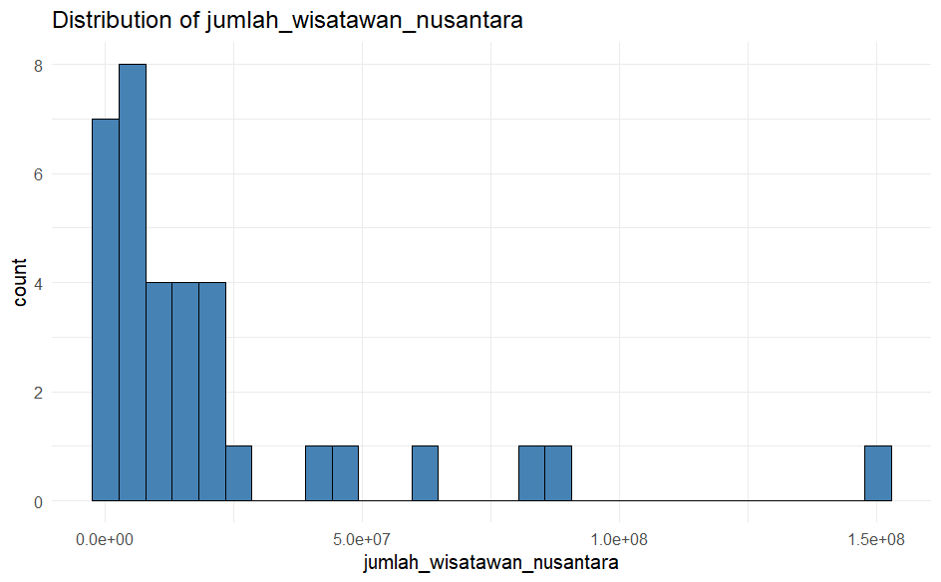
The histogram of domestic tourist number reveals an uneven distribution across Indonesian provinces, characterized by a right skewed pattern. Most provinces fall into a lower categories of tourist arrivals, as indicated by the taller bars on the left side of the graph. In contrast, only a few provinces record significantly high tourist numbers, reflected by the shorter bars on the right side. This distribution pattern highlights a substantial disparity among provinces in attracting domestic tourists, which may be attributed to variations in tourism appeal, available facilities, and accessibility.

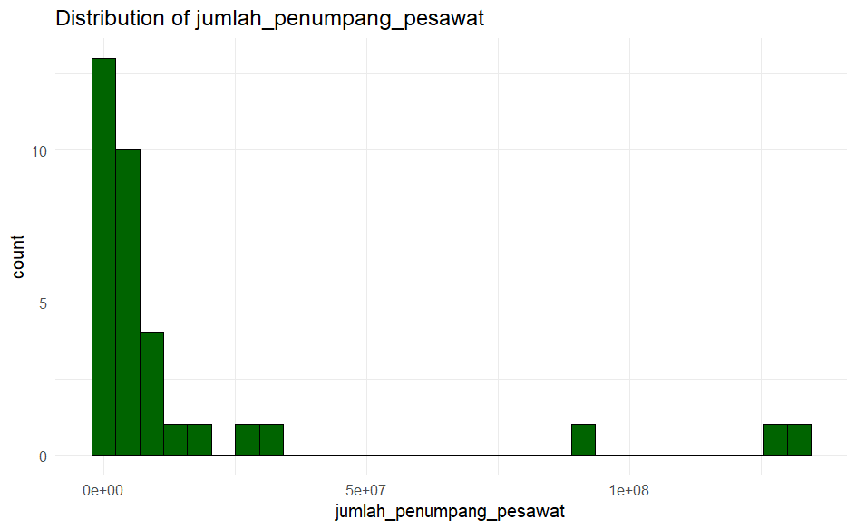
The histogram of air passenger numbers exhibits a right skewed distribution, with the majority of provinces falling into the lower categories of air traffic volume. This evidenced by the prevalence of tall bars on the left side of the graph. In contrast, only a few provinces register significantly high numbers of air passengers, as reflected by the shorter bars on the right side. This pattern indicates a disparity in air passenger distribution across provinces, likely influenced by differences in airport activity levels, population density, and the provinces’ roles as hubs of air transportation.

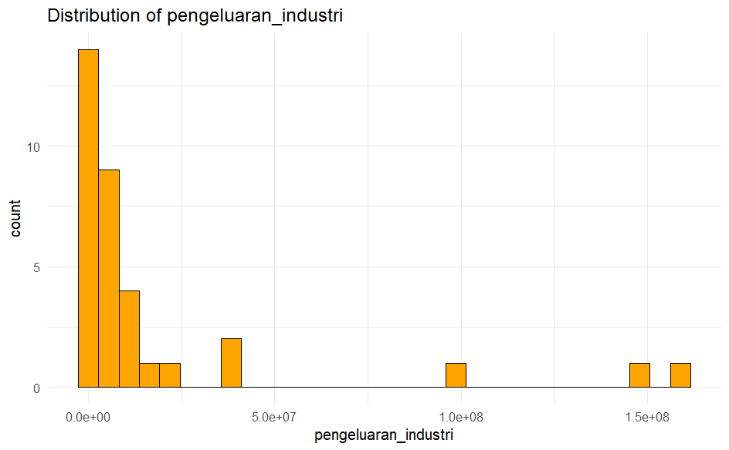
The histogram of industrial expenditure displays a right skewed distribution, with most provinces falling into the lower expenditure categories, as indicated by the tall bars on the left side of the graph. Only a few provinces report exceptionally high industrial spending, reflected by the smaller bars scattered on the right side of the graph. This pattern illustrates a significant disparity in industrial activity or scale across provinces in Indonesia.

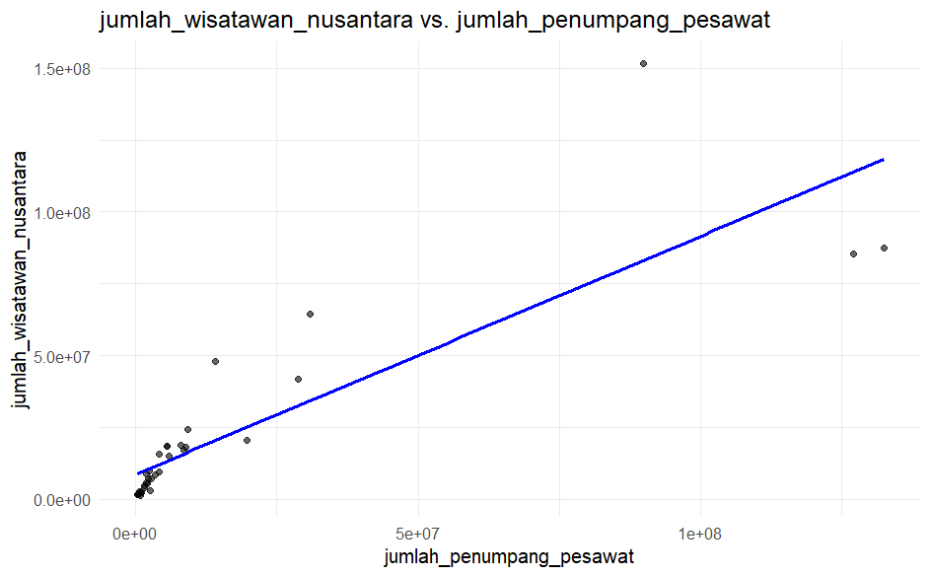
This scatter plot demonstrates a positive relationship between the number of air passengers and the number of domestic tourists. Most data points are concentrated near the origin on both axes, with only a few provinces exhibiting exceptionally high values for both variables, appearing as outliers. The blue linear regression line suggests that, in general, provinces with higher number of air passengers tend to record greater numbers of domestic tourists.

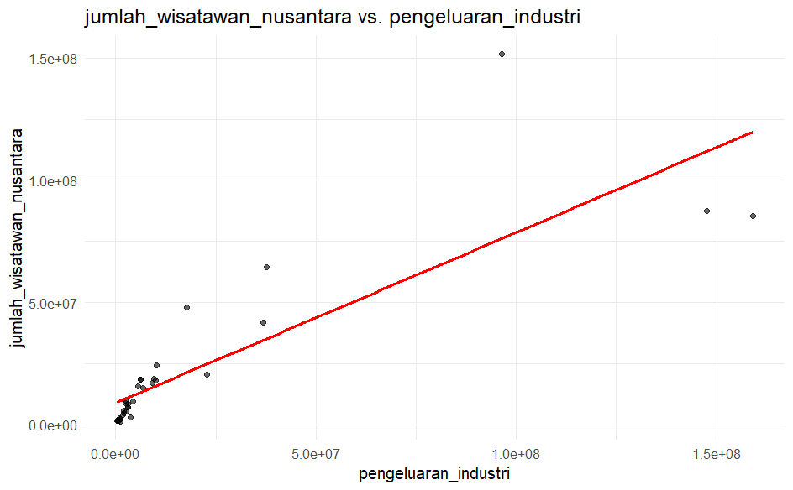
This scatter plot illustrates that most provinces have relatively low levels of industrial expenditure and domestic tourist numbers, as indicated by the clustering of data points near the origin on both axes. A few provinces appears as outliers, exhibiting significantly higher values in both variables. The red linear regression line indicates a positive trend, suggesting that provinces with greater industrial expenditure tend to attract a higher number of domestic tourists.

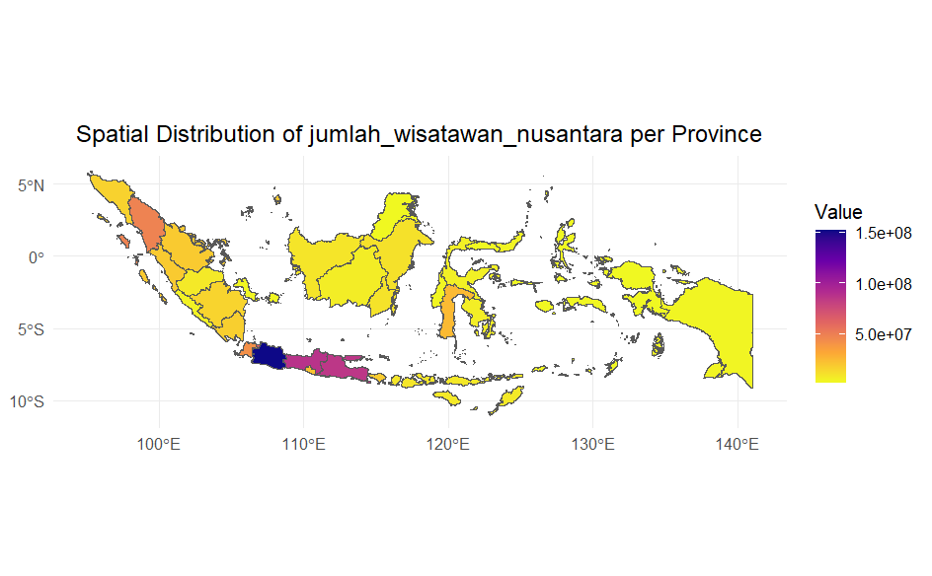
This map illustrates the spatial distribution of domestic tourist numbers by province during the 2019–2023 period. It is evident that provinces on the island of Java, particularly West Java, dominate in terms of tourist visits, as indicated by the dark blue to purple color gradient. Several provinces in Sumatra, such as North Sumatra and West Sumatra, also show relatively high tourism intensity. In contrast, most areas in Kalimantan, Sulawesi, Maluku, and Papua fall into the lower tourist categories, represented by yellow shades, highlighting a disparity in tourism activity across regions. This pattern suggests that domestic tourism remains concentrated in the western part of Indonesia, particularly in Java and parts of Sumatra.

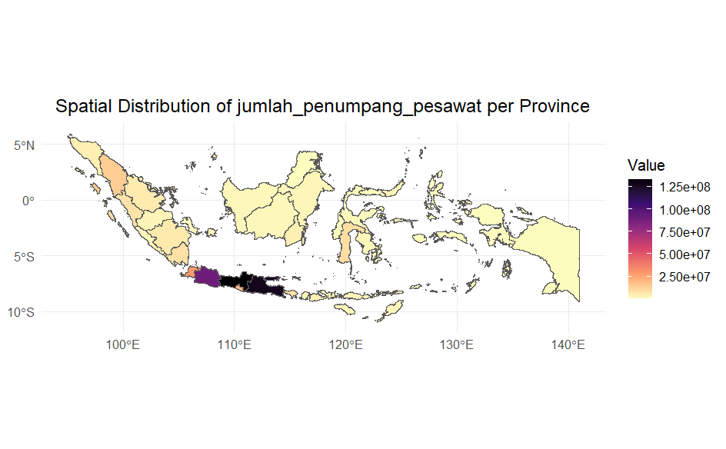
The map above illustrates the spatial distribution of domestic air passenger volume in Indonesia for the year 2023, representing the sum of arriving and departing passengers in each province. The visualization reveals that provinces on the island of Java, particularly DKI Jakarta, West Java, and East Java records exceptionally high passenger volumes, as indicated by the darkest shades on the legend scale. This reflects the central role of these regions as hubs of economic activity, government administration, and national transportation connectivity. In contrast, provinces outside Java generally exhibit significantly lower passenger numbers, highlighting a disparity in the intensity of domestic air mobility across regions.
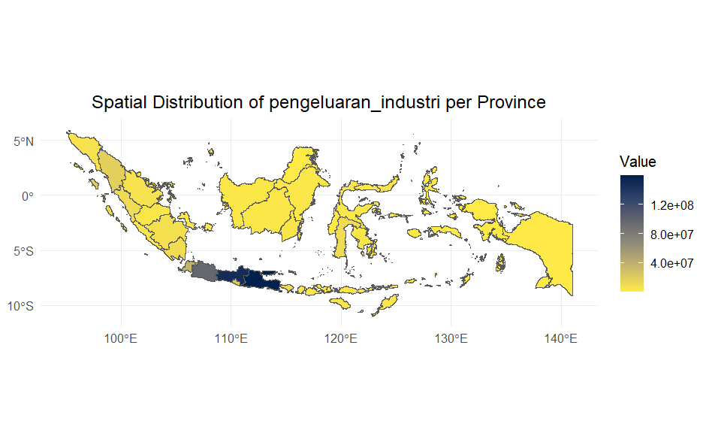
This map presents the spatial distribution of labor expenditure in micro and small-scale industries by province for the year 2023. Overall, the spatial pattern closely mirrors that of domestic tourist distribution, with the island of Java, particularly West Java, Central Java, and East Java, emerging as primary hubs of industrial activity, as indicated by the dark blue shades representing high expenditure levels. In contrast, most provinces outside Java appear in yellow, signifying lower levels of expenditure. This pattern reflects structural economic disparities across regions, where areas with high tourism concentration tend to overlap with centers of micro and small industrial activity, highlighting a connection between a region’s attractiveness and its economic strength.
- Spatial Dependence

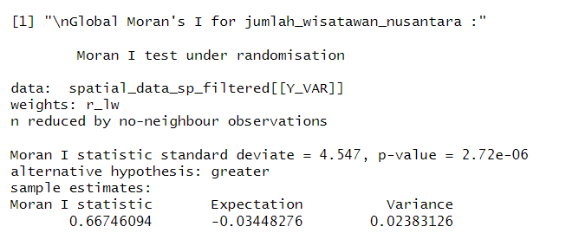
The result of Global Moran’s I test for the variable jumlah_wisatawan_nusantara yields a Moran’s I statistic of 0.667, with a standard deviation of 4.547 and p-value of 2.72e-06. Since the p-value is substantially lower than the 0.05 threshold, the result is statistically significant, indicating the presence of positive spatial autocorrelation in the data. In other words, provinces with high numbers of domestic tourists tend to be adjacent to other provinces with similarly high tourist numbers, and the same applies to provinces with low values. The negative expected value (-0.034) implies that no spatial pattern would be expected under a random distribution. However, the observed Moran’s I value being considerably higher than this expectation confirms the existence of spatial clustering, or the concentration of regions with similar characteristics in terms of domestic tourist visits.

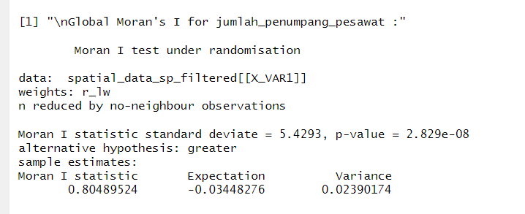
The result of Global Moran’s I test for the variable jumlah_penumpang_pesawat indicates a highly significant positive spatial autocorrelation. The Moran’s I value of 0.8049, with an expected value of -0.0345 and a p-value of 2.829e-08, suggests that the distribution of air passenger numbers is not random but forms a structured spatial pattern. This means that regions with high air passenger volumes tend to be located near other regions with similarly high volumes, and likewise for regions with low volumes. The z-score (standard deviate) of 5.4293 further reinforces the statistical significance of this spatial pattern.
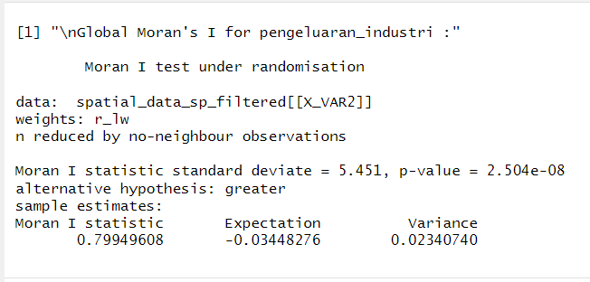
The result of the Global Moran’s I test for the pengeluaran_industri variable indicates a highly significant positive spatial autocorrelation. The Moran’s I value of 0.79949, with an expected value of -0.0345 and a p-value of 2.504e-08, suggests that the distribution of industrial expenditure is not random but forms a structured spatial pattern. This means that regions with high levels, and likewise for regions with lower values. The extremely low p-value confirms that this spatial autocorrelation is statistically significant, allowing us to reject the null hypothesis of no spatial autocorrelation.
- Model Analysis
D.1. OLS (Ordinary Least Squares)
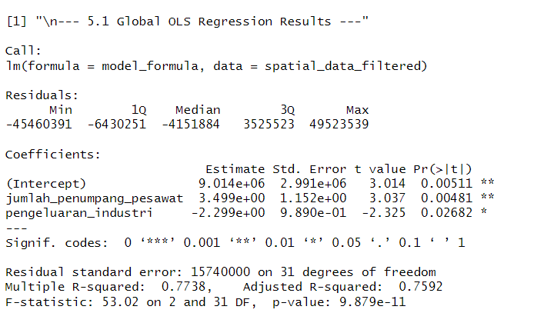
The result of Ordinary Least Squares (OLS) regression analysis indicate that both the number of ait passengers and industrial expenditure have a statistically significant influence on the number of domestic tourists at the provincial level. This significance is supported by p-values for both variable being less than 0.05, suggesting sufficient statistical evidence that these variables contribute meaningfully to variations in tourist visits.
The coefficient for the number of air passengers is 3.499, indicating that an increase in air passenger volume is associated with a higher number of domestic tourists. In contrast, the industrial expenditure variable has a coefficient of -2.299, suggesting a negative correlation—higher industrial spending is associated with a decrease in domestic tourist numbers.
The model yields an R-squared value of 0.7738 and an adjusted R-squared of 0.7592, meaning that approximately 77% of the variation in domestic tourist numbers can be explained by the two independent variables in the model.

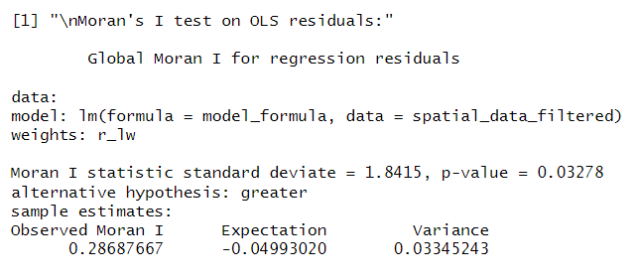
To assess the presence of spatial patterns in the residuals of the OLS model, a Moran’s I test was conducted. The test yielded a Moran’s I value of 0.2869 with a p-value of 0.03278. Since the p-value is below the 0.05 significance threshold, it can be concluded that there is statistically significant spatial autocorrelation in the residuals of the OLS model. This indicates that the model’s residuals are not randomly distributed but instead form a discernible spatial pattern. Consequently, the assumption of residual independence in the OLS model is violated, suggesting the need for further spatial modeling to capture local variation, spatial effects, and more complex interrelationships between variables in a geographic context.
D.2. GWR (Geographically Weighted Regression)
D.2.1 GWR with Adaptive Gaussian Kernel
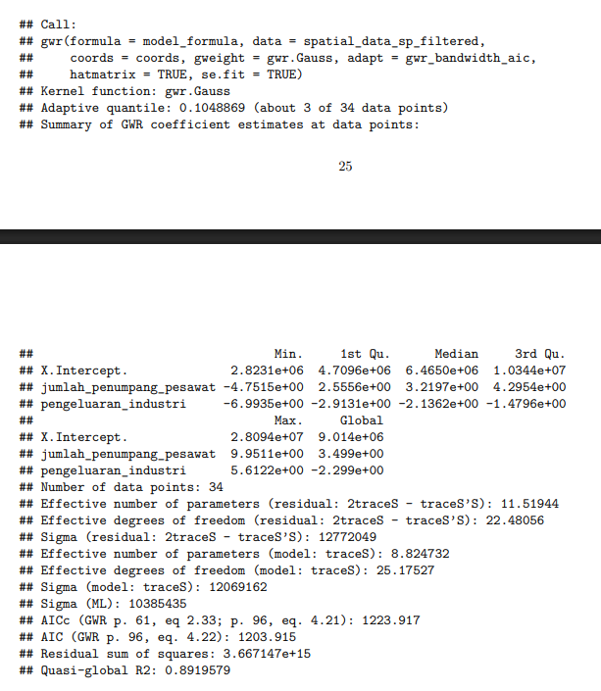

Based on the results of the Geographically Weighted Regression (GWR) analysis using a Gaussian kernel function with an adaptive bandwidth, the model was built using 34 data points with an adaptive quantile of 0.1048869, indicating that local estimations are based on approximately 3 nearby data points. The model evaluates the influence of two independent variables jumlah_penumpang_pesawat(number of air passengers) and pengeluaran_industri (industrial expenditure) on the dependent variable. The local coefficient estimates show spatial variability, with jumlah_penumpang_pesawat ranging from -4.7515 to 9.9511, and pengeluaran_industriranging from -6.9935 to 5.6122. At the global level, jumlah_penumpang_pesawat has a positive effect (3.499), while pengeluaran_industri shows a negative effect (-2.299) on the outcome. The quasi-global R² value of 0.8919579 indicates that approximately 89% of the variation in the dependent variable is explained by the model, reflecting strong model performance. The AIC value of 1203.915 suggests that the model is statistically well-fitted, while the sigma and degrees of freedom values demonstrate the model’s complexity. Overall, GWR provides a deeper understanding than standard linear regression by revealing that the influence of predictor variables on the outcome varies across geographic locations.

D.2.2 GWR with Fixed Gaussian Kernel
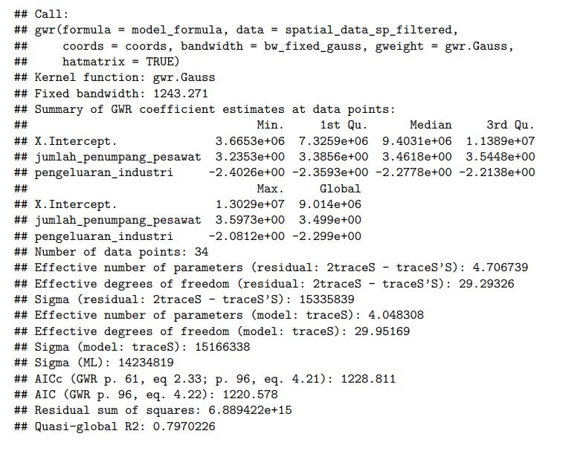
Based on the results of the Geographically Weighted Regression (GWR) analysis using a Gaussian kernel with a fixed bandwidth of 1243.271, the model was developed from 34 spatial data points. The analysis examines the relationship between the dependent variable and two independent variables: jumlah_penumpang_pesawat (number of air passengers) and pengeluaran_industri (industrial expenditure). The local coefficient estimates vary across locations, indicating spatial heterogeneity. The coefficient for jumlah_penumpang_pesawat ranges from 3.2353 to 5.9379, while for pengeluaran_industri it ranges from -2.4026 to -2.0812. These values suggest that the number of air passengers consistently has a positive impact on the outcome, whereas industrial expenditure has a negative effect. The global coefficients also reflect this trend, with jumlah_penumpang_pesawatat 3.4990 and pengeluaran_industri at -2.2990. The quasi-global R² value of 0.7970262 indicates that approximately 79.7% of the variation in the dependent variable is explained by the model, suggesting a strong overall fit. Additionally, AIC values (1220.578 and 1228.811) support the model’s adequacy, while the residual sum of squares (6.889422e+15) and sigma values reflect the model’s residual variability. These results confirm that GWR with a fixed bandwidth effectively captures the spatially varying relationships between the predictors and the response variable.

D.2.3 GWR with Adaptive Bisquare Kernel
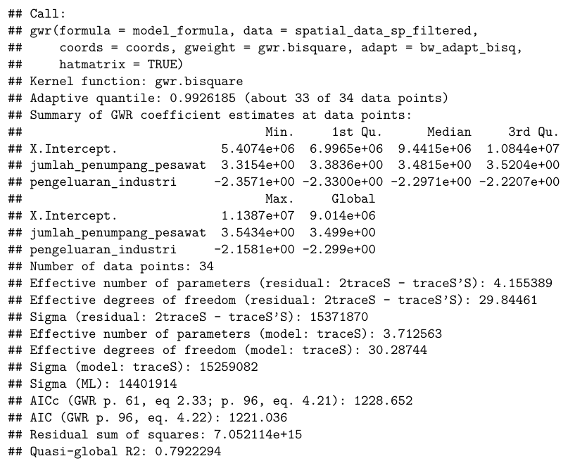
Based on the results of the Geographically Weighted Regression (GWR) analysis using a bisquare kernel function with an adaptive bandwidth (quantile = 0.9926185), the model was built from 34 spatial data points. This adaptive setting implies that approximately 33 out of 34 neighboring points were considered for each local regression. The analysis focuses on two independent variables jumlah_penumpang_pesawat (number of air passengers) and pengeluaran_industri (industrial expenditure)—and their spatially varying effects on the dependent variable. The coefficients for jumlah_penumpang_pesawat range from 3.3154 to 3.5434, indicating a consistent and moderately strong positive influence across locations. In contrast, pengeluaran_industri has negative coefficients ranging from -2.3571 to -2.1581, reflecting a stable negative relationship with the dependent variable throughout the study area. The global coefficients support these patterns, with values of 3.4990 for air passengers and -2.2990 for industrial expenditure. The model’s quasi-global R² value of 0.7922294 indicates that approximately 79.2% of the variation in the dependent variable is explained, suggesting a strong overall model fit. Additionally, the low residual sum of squares (7.052114e+15), along with AIC values of 1220.464 and 1228.652, further confirm the adequacy of the model. These results demonstrate that the GWR model with an adaptive bisquare kernel effectively captures the spatial heterogeneity in the relationships between predictor variables and the outcome.
D.2.4 GWR with Fixed Bisquare Kernel
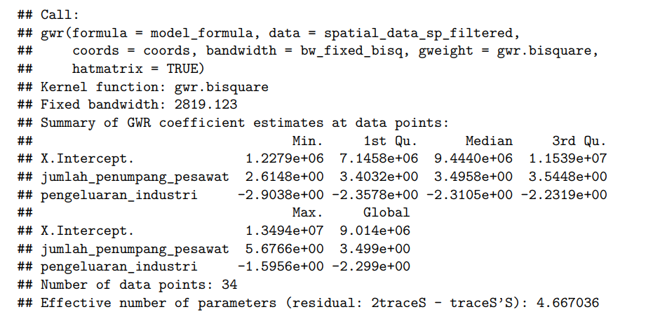
The results of the Geographically Weighted Regression (GWR) using a bisquare kernel function with a fixed bandwidth of 2819.123 show the spatial variation in the influence of two independent variables jumlah_penumpang_pesawat (number of air passengers) and pengeluaran_industri (industrial expenditure) on the dependent variable across 34 locations. The local coefficient estimates indicate that jumlah_penumpang_pesawat has a positive effect throughout the study area, with values ranging from 2.6148 to 5.6766 and a global average of 3.4990. On the other hand, pengeluaran_industri consistently exhibits a negative impact, with coefficients ranging from -2.9038 to -1.5956 and a global value of -2.2990. This suggests that increases in air passenger numbers are generally associated with increases in the dependent variable, while higher industrial expenditure tends to correlate with a decrease. The intercept term also varies significantly across space, reflecting local baseline differences. The model includes 34 spatial data points and has an effective number of parameters of 4.667036, indicating moderate model complexity. Overall, the fixed bisquare GWR model successfully captures spatial heterogeneity in the relationships between the predictor variables and the dependent variable, emphasizing the importance of considering spatial context in regression analysis.
D.2.5. Models Perfomance
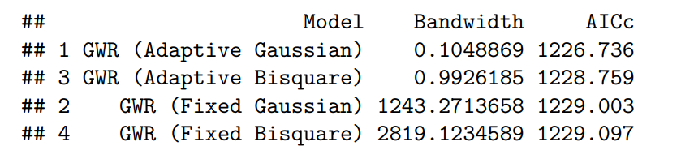
The table above presents a comparison of four Geographically Weighted Regression (GWR) models based on the combination of kernel types (Gaussian vs. Bisquare) and bandwidth approaches (Adaptive vs. Fixed). The primary criterion used to evaluate model performance is the Corrected Akaike Information Criterion (AICc), where lower values indicate a better trade-off between model fit and complexity.
Among the four models, the GWR with Adaptive Gaussian kernel achieves the lowest AICc value of 1226.736, indicating it provides the best overall performance in capturing spatial variation in the data. This model also uses the smallest bandwidth (0.1049), which suggests it adjusts the spatial extent of influence for each observation based on local data density. This is particularly advantageous for spatial datasets with uneven geographic distributions—such as those found in Indonesia.
In contrast, the Fixed Bisquare kernel model applies a large, uniform bandwidth of 2819.12, and yields a slightly higher AICc of 1229.097, indicating a less flexible model that may underperform in regions with localized spatial variation.

D.3. GWLR (Geographically Weighted Logistic Regression)
D.3.1. GWLR with Adaptive Gaussian Kernel
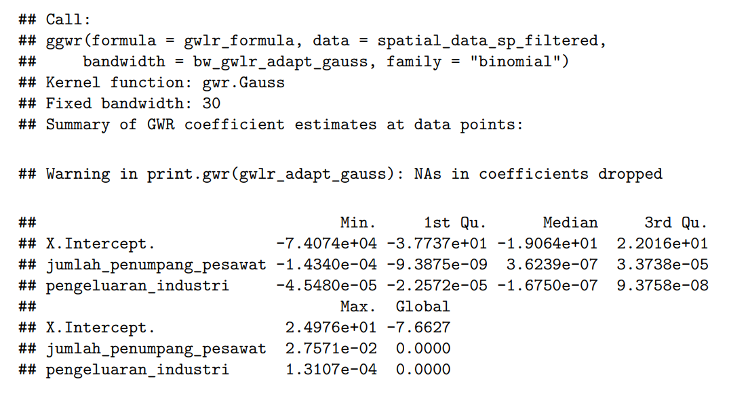
The GWLR results using an adaptive Gaussian kernel reveal spatial variation in how predictors influence the likelihood of a province being classified as a major tourism destination. The intercept values range widely, from -74,070 to 24,970, showing that the baseline odds differ significantly across provinces.
The local coefficients for jumlah_penumpang_pesawat (air passenger volume) range from -1.43 to 2.76, with a median of 0.62. In most areas, higher air passenger volume increases the probability of being a tourism hub, though in some regions the effect is negative, possibly due to differing airport functions.
For pengeluaran_industri (industrial expenditure), coefficients vary from -4.58 to 1.31, with a median of -1.67. Most provinces show a negative relationship, suggesting industrial focus may reduce tourism emphasis, though a few areas show positive effects. The global coefficient for this variable is zero, emphasizing the need to examine local contexts.

D.3.2. GWLR with Fixed Gaussian Kernel
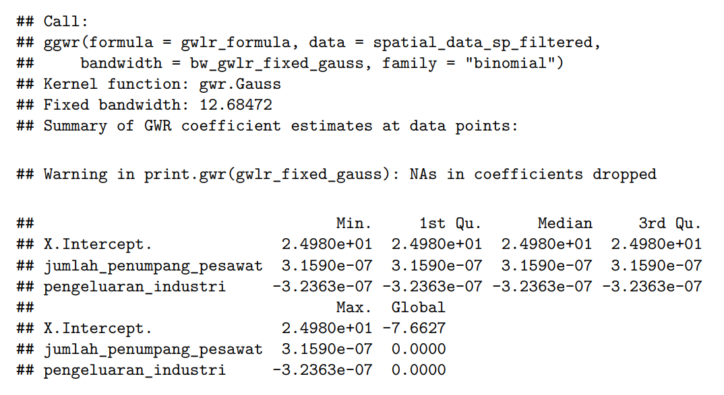
The GWLR output with a fixed Gaussian kernel and a fixed bandwidth of approximately 12.68 reveals minimal spatial variation in the model's coefficients across provinces. The intercept shows a constant value of approximately 24.98 at all quartiles, suggesting no spatial variability in the baseline log-odds of a province being classified as a major tourism destination.
The local coefficients for jumlah_penumpang_pesawat (air passenger volume) are uniform across the dataset, with values fixed at 3.159e-07 for all statistical summaries (min, 1st quartile, median, and 3rd quartile). This indicates a stable and very weak positive relationship between air passenger volume and tourism classification that does not vary by location.
Similarly, pengeluaran_industri (industrial expenditure) also exhibits no spatial variation, with all local coefficient values consistently equal to -3.2363e-07. This uniformity suggests a weak and constant negative association with the tourism outcome. The lack of variability in these coefficients implies that the fixed kernel configuration failed to capture local spatial dynamics present in the data.

D.3.3. GWLR with Adaptive Bisquare Kernel
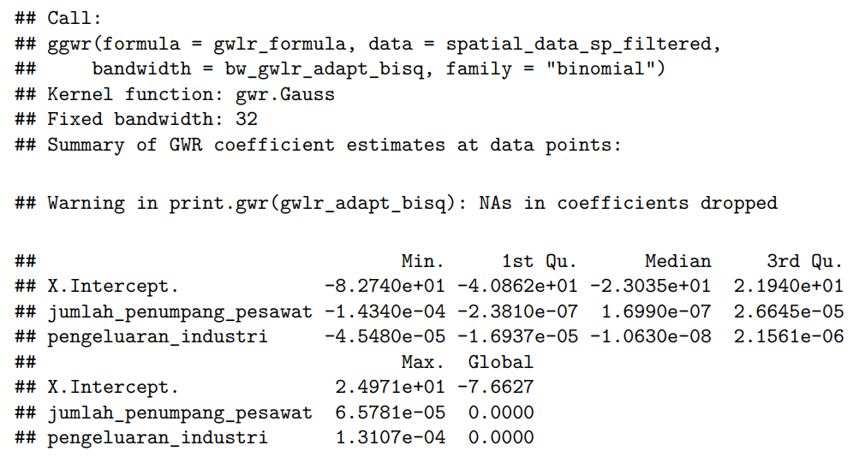
The GWLR result using an adaptive bisquare kernel with a fixed bandwidth of 32 shows clear spatial variation in predictor effects across provinces. The intercept ranges from approximately -82.74 to 21.94, with a median of around -21.30, indicating substantial differences in the baseline log-odds of being classified as a major tourism destination across locations.
The local coefficients for jumlah_penumpang_pesawat (air passenger volume) vary between -1.434e-05 and 2.065e-05, with a median of about 1.699e-05. This suggests that in most areas, greater air passenger volume slightly increases the odds of being a tourism destination, though in some locations the relationship is weakly negative.
For pengeluaran_industri (industrial expenditure), the coefficients also vary spatially, ranging from -4.548e-05 to 2.165e-06, with a median of approximately -1.063e-05. Most provinces show a weak negative association, though there are areas with slightly positive effects, reinforcing the spatial heterogeneity of the relationship. The global coefficients are small in magnitude, but the local results highlight subtle regional differences that a global model would overlook.

D.3.4. GWLR with Fixed Bisquare Kernel
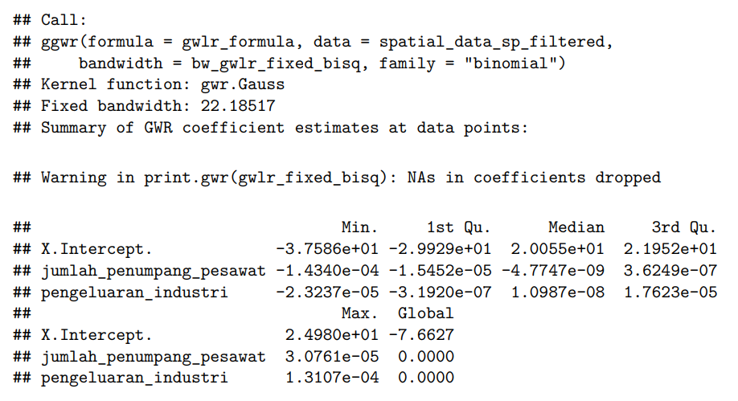
The GWLR result using a fixed bisquare kernel with a bandwidth of approximately 22.19 shows moderate spatial variation in the local coefficients. The intercept values range from -37.85 to 21.95, with a median of about 0.21, indicating variability in the baseline log-odds across provinces. This suggests that some regions are much less likely, and others more likely, to be classified as major tourism destinations in the absence of predictor effects.
The local coefficients for jumlah_penumpang_pesawat (air passenger volume) range from -1.434e-04 to 6.249e-07, with a median of -4.774e-05. This implies that the effect of air passenger volume on tourism classification is mostly negative, though the strength of that relationship varies across space.
For pengeluaran_industri (industrial expenditure), coefficients vary from -2.33e-04 to 1.76e-05, with a median of about -1.09e-05. While the general tendency is negative, indicating that higher industrial expenditure slightly reduces the likelihood of being a tourism hub, the variation again reflects spatial heterogeneity. The global coefficients are minimal, further emphasizing the importance of considering localized patterns through spatial modeling.

Conclusion
This study explored the spatial dynamics of domestic tourism in Indonesia by assessing how air travel accessibility and industrial expenditure influence tourism patterns across provinces Through a comparative modeling framework, we employed Ordinary Least Squares (OLS), various configurations of Geographically Weighted Regression (GWR), and Geographically Weighted Logistic Regression (GWLR) to evaluate both global and local spatial relationships.
The OLS model provided an initial understanding of the general associations between the predictors and domestic tourist numbers. It showed that air passenger volume has a statistically significant positive effect, while industrial expenditure tends to be negatively associated with tourism. However, Moran’s I test on the residuals revealed significant spatial autocorrelation, indicating that OLS assumptions were violated and that the model was insufficient for capturing spatial heterogeneity.
GWR models were then implemented using different kernel and bandwidth strategies. Among them the adaptive Gaussian kernel achieved the best performance with the lowest AICc (1226.736) and the highest $R^{2}$ (0.8919). The model revealed strong spatial non-stationary in predictor effects, highlighting that the relationship between tourism and its drivers differs widely across regions.
In parallel, GWLR was used to evaluate the likelihood of a province being classified as a major tourism destination. GWLR models with adaptive kernels captured important local variations, while fixed kernel models showed limited responsiveness to spatial differences. The adaptive models revealed that both predictors could have positive or negative effects depending on geographic context.
Altogether, the results confirm that domestic tourism patterns in Indonesia are shaped by complex and localized interactions between accessibility and economic conditions. Adaptive spatial models like GWR and GWLR offer deeper insight compared to global approaches and should be considered essential tools for informing regionally tailored tourism development strategies.
References
- Brunsdon, C., Fotheringham, A. S., & Charlton, M. E. (1998). Geographically weighted regression: a method for exploring spatial nonstationarity. Geographical Analysis, 28(4), 281–298.
- Anselin, L. (1995). Local indicators of spatial association—LISA. Geographical Analysis, 27(2), 93–115.
- Goodchild, M. F. (2007). Citizens as sensors: the world of volunteered geography. GeoJournal, 69(4), 211–221.
- Getis, A., & Ord, J. K. (1992). The analysis of spatial association by use of distance statistics. Geographical Analysis, 24(3), 189–206.
- Fotheringham, A. S., Brunsdon, C., & Charlton, M. (2002). Geographically Weighted Regression: The Analysis of Spatially Varying Relationships. Wiley.
- Novianti, P., Gunardi, & Rosadi, D. (2023). Geographically Weighted Logistic Regression Model on Binomial Data. Engineering Letters, 31(3), 1–10.
- Anselin, L. (1988). Spatial Econometrics: Methods and Models. Kluwer Academic Publishers.
- Brunsdon, C., Fotheringham, A. S., & Charlton, M. E. (1998). Geographically weighted regression: Modelling spatial non-stationarity. Journal of the Royal Statistical Society: Series D (The Statistician), 47(3), 431–443.
- Nakaya, T., Fotheringham, A. S., Brunsdon, C., & Charlton, M. (2005). Geographically weighted Poisson regression for disease association mapping. Statistics in Medicine, 24(17), 2695–2717.

